Double up statistics
Software Requirements Specification
Version 1.0

Table of contents
1. Glossary 3
2. Overall description 4
3. Main functionality 5
3.1. Double Up Statistics Report 5
3.2. Double Up Detail Report 8
3.3. Notifications about Double Up activity 10

Glossary
Casino Manager (CM) – BSG back-office system, through which promotional campaigns can be created and the necessary reports on ongoing and completed promotions are available.
Double up – game mechanic in which the player bets either the entire amount or half from the winnings of the last round, then chooses one of the two buttons - heads or tails – and then either takes the winnings in the form of double bet or loses them.
Double up notifications – a message to the licensee that a particular player has used (and won from) the Double Up feature N times in one gaming session.
Player Game Info – report in the CM, which displays information about the game sessions of a particular player.
Reports & Statistics – section in CM with reports of various statistics about financial matters, game sessions, bonuses etc.
Sorting parameters - a set of options in which the user specifies the criteria for selecting data for the report.

Overall description
Double up statistics – block of new reports and notifications aimed at counting the statistics on players' usage of the «Double up» function in games (slot and table games). Basically, such report is made either for all users for a certain period, or for one user.
The calculation of the function usage will be made only in case if the bet in «Double Up» will lead to the winning. In addition to that, the report also shows total bets and wins of double up per game session. More details are described in the section «Double Up Statistics Report».
If player uses the Double up function more than N times in one game session, a notification will be sent to the licensee with information about the player and his game session. The number of times will be determined in the licensee's bank settings and can be changed upon request. Such functionality allows to keep track of all changes in statistics and to react to them promptly.
- Main functionality
The functionality of double up counting consists of sections:
- Double Up Statistics Report.
- Detail Double Up Report.
- Notifications about Double up activity.
  - Double Up Statistics Report
This report located in the section «Reports & Statistics» and represents a table with a list of data of gaming sessions of users, in which they used the function Double up, as well as their bets and winnings on this function.
The CM user needs a set of tools to refine the data sampling for the report. For this purpose, the system provides a set of parameters, which are described in Table 1.
Table 1. Sorting parameters
№ | Title | Description | Type | Mandatory
Information about casino (or a path to users’ location)
1. | Cluster | A list of cluster names on which the subcasinos are located. | Select | Yes
2. | Subcasino | A list of subcasino’s names, that are located on the cluster. User can choose from one to all subcasinos. | Multi-select | Yes
3. | Bank | A list of banks’ names, that are located on the subcasino. User can choose from one to all banks. |  | Yes
Session Info
4. | Start Date and Time | The starting date and time of the period to view the double up usage sessions.  Timezone should be based on user Casino Manager settings. | Date/Time | Yes
5. | End Date and Time | The date and time of the end of the search period for the double up usage sessions.  Timezone should be based on user Casino Manager settings. | Date/Time | Yes
Player Info
6. | Account | List with three values:  - All  - Test  - Live  Helps to divide all test players’ data from live ones. | Select | No  (All by default)
7. | Language | Filter setting to sort out players with specific language. | Select | No  (All by default)
Game Info
8. | Platform | List of values:  - All  - Flash  - Win32  - Air  - Mobile  - Android  - iOS  - Windows Phone  - Vault  Describes a platform from which player started a game. | select | No  (All by default)
Columns and rows of the report and their descriptions are presented in Table 2.
Table 2. Double Up Statistics Report fields
№ | Title | Description | Type
1. | Ext. ID | External user ID. | link
2. | Start time | Starting time of the session | Date/time
3. | End time | Ending time of the session | Date/time
4. | Double Up Count | The number of rounds of the double up function in all sessions of a particular user.  This field redirects user to Double up report info about one user. | Integer
5. | Double up bets | Sum of all bets in Double up in all user’s sessions, which led to a win situation. | Float
6. | Double up wins | Sum of all wins in Double Up in all user’s sessions. | Float
Row with total values contains
7. | Total of double ups | Total number of uses of double up function for all players in the table. | Integer
8. | Total bets | Total sum of all players’ bets. | Float
9. | Total wins | Total sum of all players’ winnings. | Float
An example of a report page is shown in Figure 1.
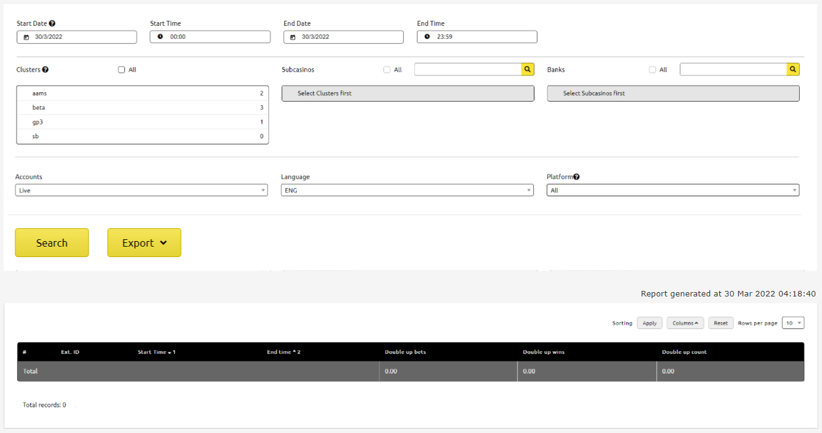
Figure 1. Layout of Double Up Statistics Report
Once the user has defined all the report parameters, he can use the functions:
- Export (XLSX/CSV) - function for exporting table data
- View detailed report about player’s double up sessions – redirects CM user to Double up report info, which shows all game sessions with double up usage of one specific player.
  - Double Up Detail Report
This report shows after clicking on Double up counts field in Double Up Statistics Report and describes all game sessions of a particular player, in which he used Double Up function and won.
Table №3. Double Up Detail Report fields
№ | Title | Description | Type
1. | Game Name | Name of the game the user played in this game session. | Text
2. | Start date and time | Starting date and time of the session. | Date/time
3. | End date and time | Ending date and time of the session. | Date/time
4. | Round count | Number of all rounds in session. | Integer
5. | Income | Sum of all bets from one session, including double ups. | Float
6. | Payout | Sum of all winnings from one game session, including double ups. | Float
7. | $ Gain/Loss | The value of profit or loss from game session. Calculated as:  $$\text{Gain/Loss}=Payout-Income$$ | Float
8. | Double Up Counts | The number of double up function usage (with a win situation) in one session.  This field redirects user to Double up report info about one user. | Integer
9. | Double up bets | Sum of all bets in Double up in one session, which led to a win situation. | Float
10. | Double up wins | Sum of all wins in Double Up in one session. | Float
11. | Start Balance | Player’s balance number, with which he launched game. | Float
12. | End Balance | Player’s balance after closing session. | Float
13. | Game Session ID | A link to the player's game session. Opens the VBA window with the session record. | Link
Row with total values contains
14. | Number of double ups | Total number of uses of double up function for all players in the table. | Integer
15. | Sum of double up bets | Total sum of all double up bets. | Float
16. | Sum of double up wins | Total sum of all double up winnings. | Float
17. | Number round count | Total sum of all rounds of all sessions | Integer
18. | Total income | Total sum of all bets of all sessions | Float
19. | Total payout | Total sum of all winnings of all sessions | Float
An example of a report page is shown in Figure 2.
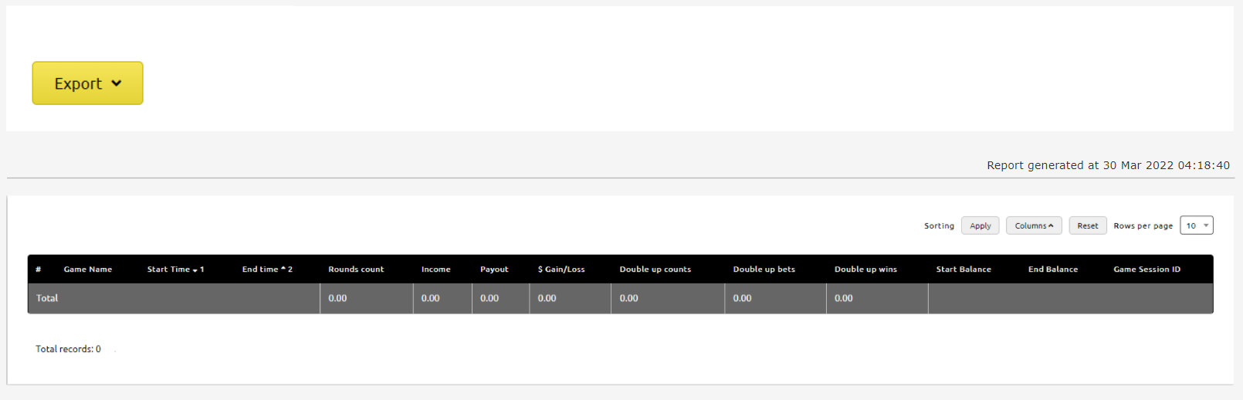
Figure 2. Double Up Detailed Report layout.

Once the user has defined all the report parameters, he can use the functions:
- Export (XLSX/CSV) - function for exporting table data
- View detailed report by session - called by clicking on Game Session ID and opens VBA window with a record of all actions inside the game session.
  - Notifications about Double Up activity
This feature is designed to notify the licensee in case of exceeding N of Double Up feature usage for one gaming session. All notifications will be sent to the licensee's email provided.
The notification email provided should be stored in bank configuration as a new parameter and should be available for change upon request.
The number of uses is determined by the parameter during the configuration of the bank and should be available for change upon the licensee's request.
All notifications should contain text similar to:
«Player [EXT_ID] used a double-up in session [GAMESESSION_ID] [N] times», where:
  - EXT_ID – external user identifier.
  - GAMESESSION_ID – identifier of the game session where the Double Up function was used N times.
  - N – number of times of Double Up function usage.

